SOLANO COMMUNITY COLLEGE
MT 164, PROGRAMMABLE LOGIC CONTROLLERS
Spring, 2018

PLC PROGRAMMING LAB 3 - ANALOG I/O
Catharine Crayne
02/19/2018

OBJECTIVE
- To wire up and write a PLC Program that uses Analog I/O.

GROUP MEMBERS

MATERIALS & EQUIPMENT
Micrologix 1100 Trainer Unit, 6 V battery, Multimeter, wires, RSLinx and RSLogix software, laptop, crossover cable.

PROCEDURE:
- Attach the Analog Module 1762-IF2OF2 to the Micrologix PLC.
- Wire up a 6V lantern battery and a potentiometer to the PLC trainer. Use the diagrams as a guide.
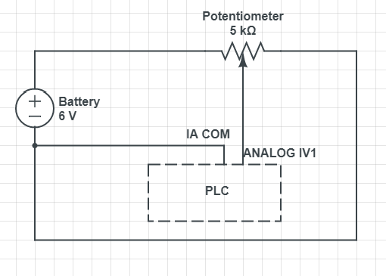

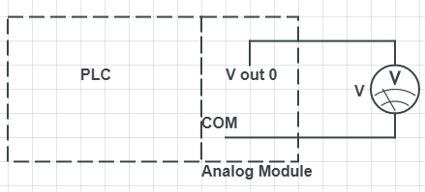

Step 2 Step 8
- Write a simple ladder logic program that “moves” the analog input value from location I:0.4 into the memory location N7:0
- Now add another ladder rung to appropriately scale that voltage to half maximum (5V = 32,767) and store it in location N7:1
- Add another rung to output that outputs that value to location O:1.0. Verify the program and download it.
- Run the program and check to see if the values change when the potentiometer is turned. Then use a multimeter to measure the min and max output on the Analog output module (COM and Vout 0).
- If it reads less that 5 V at maximum, then power off the PLC and wire in the Voltmeter to the Analog module.
- Turn on the PLC and check that the potentiometer affects the meter output. Save your program or screenshot it to use in your lab write up.
- Part 2: Write a simple ladder logic program that uses a green switch to enable the output of the above circuit. Download it and verify it works.
- Now update your program so that the green switch latches when pressed and use the safety disconnect switch (NC) to unlatch it to stop the output to the meter.
- Download this program and verify it works. Save it or screenshot it to use in your lab write up.

RESULTS - DATA
Steps 3-5: Snapshot of our program. Please note that the Source for Memory_Location_2 and Output_1 was later corrected to N7:0.
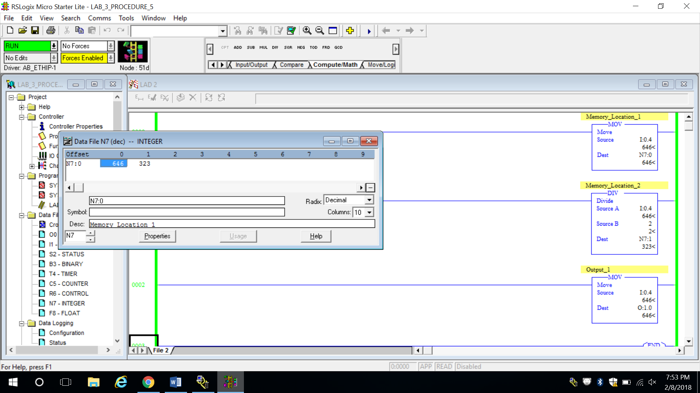

Step 8: Snapshot of our program. Please note that the Source for Memory_Location_2 and Output_1 was later corrected to N7:0.
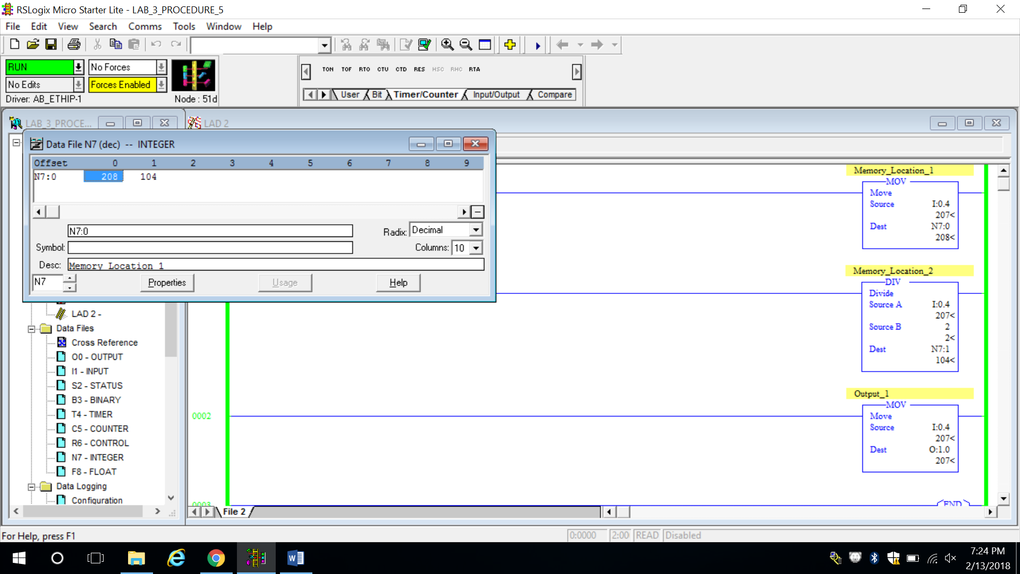

Step 9: Snapshot of our program.
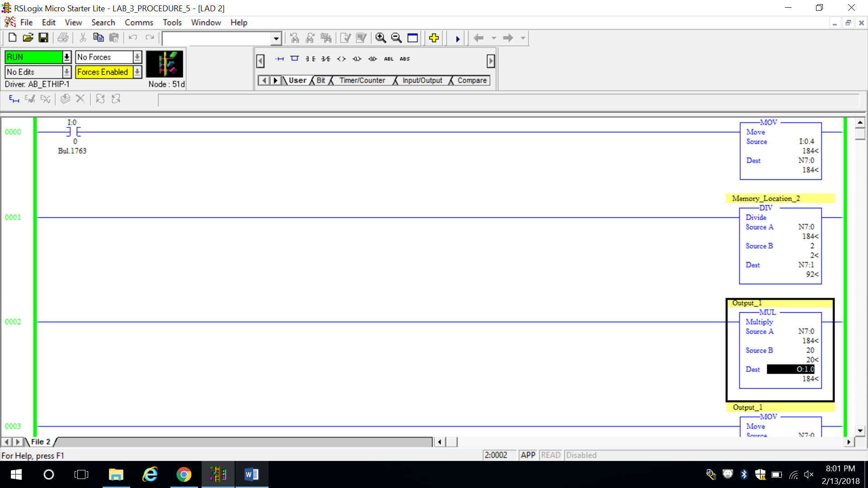

Step 10-11: Snapshot of our program.
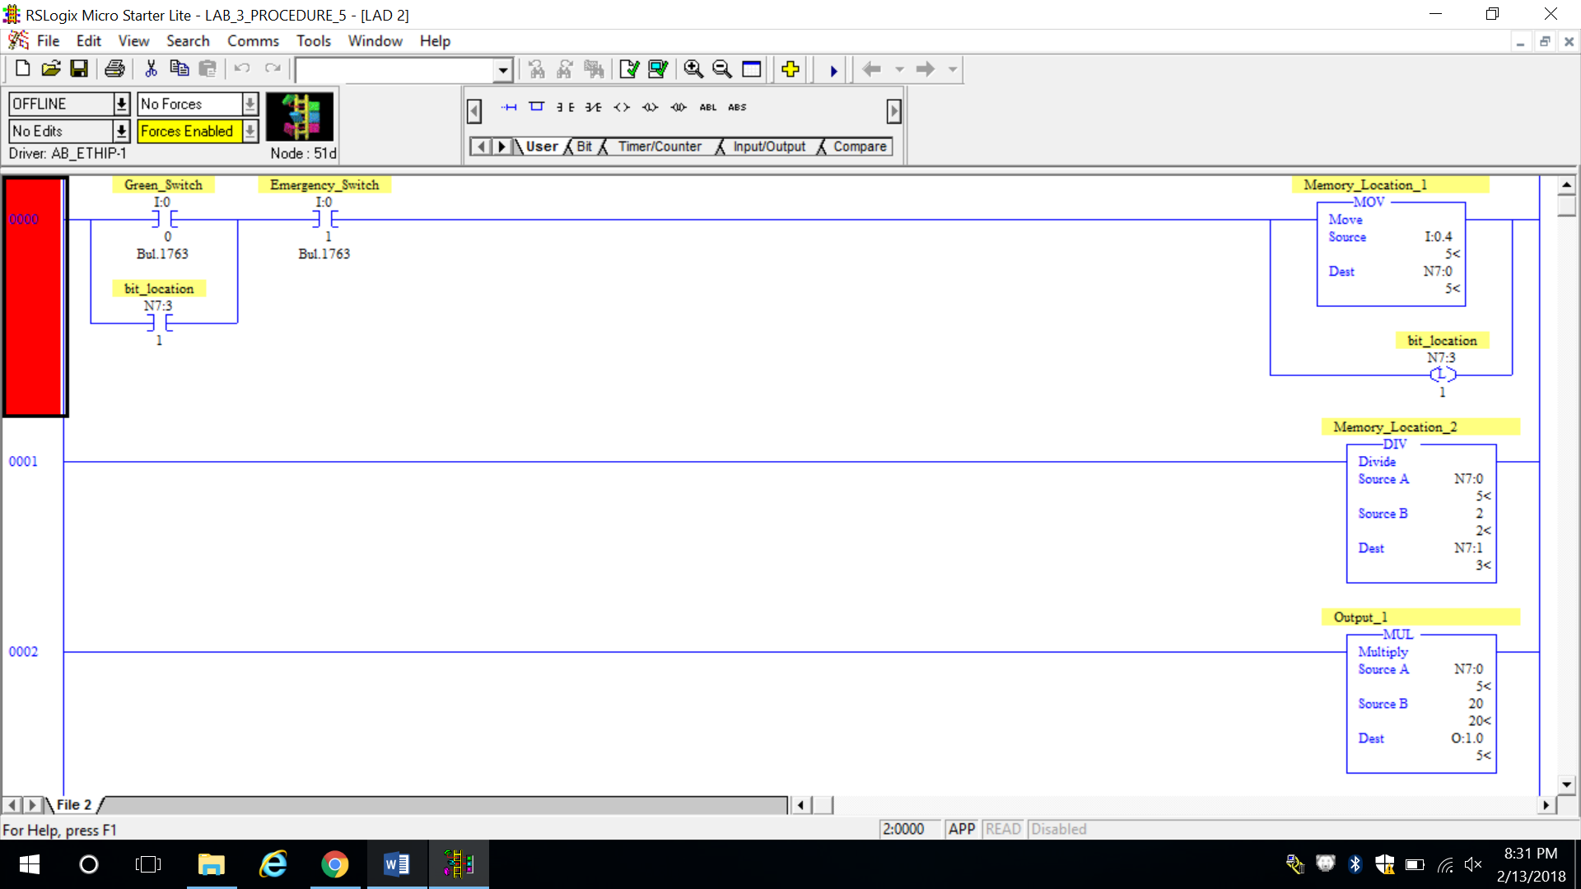

OBSERVATIONS
Step 2: Picture of our setup
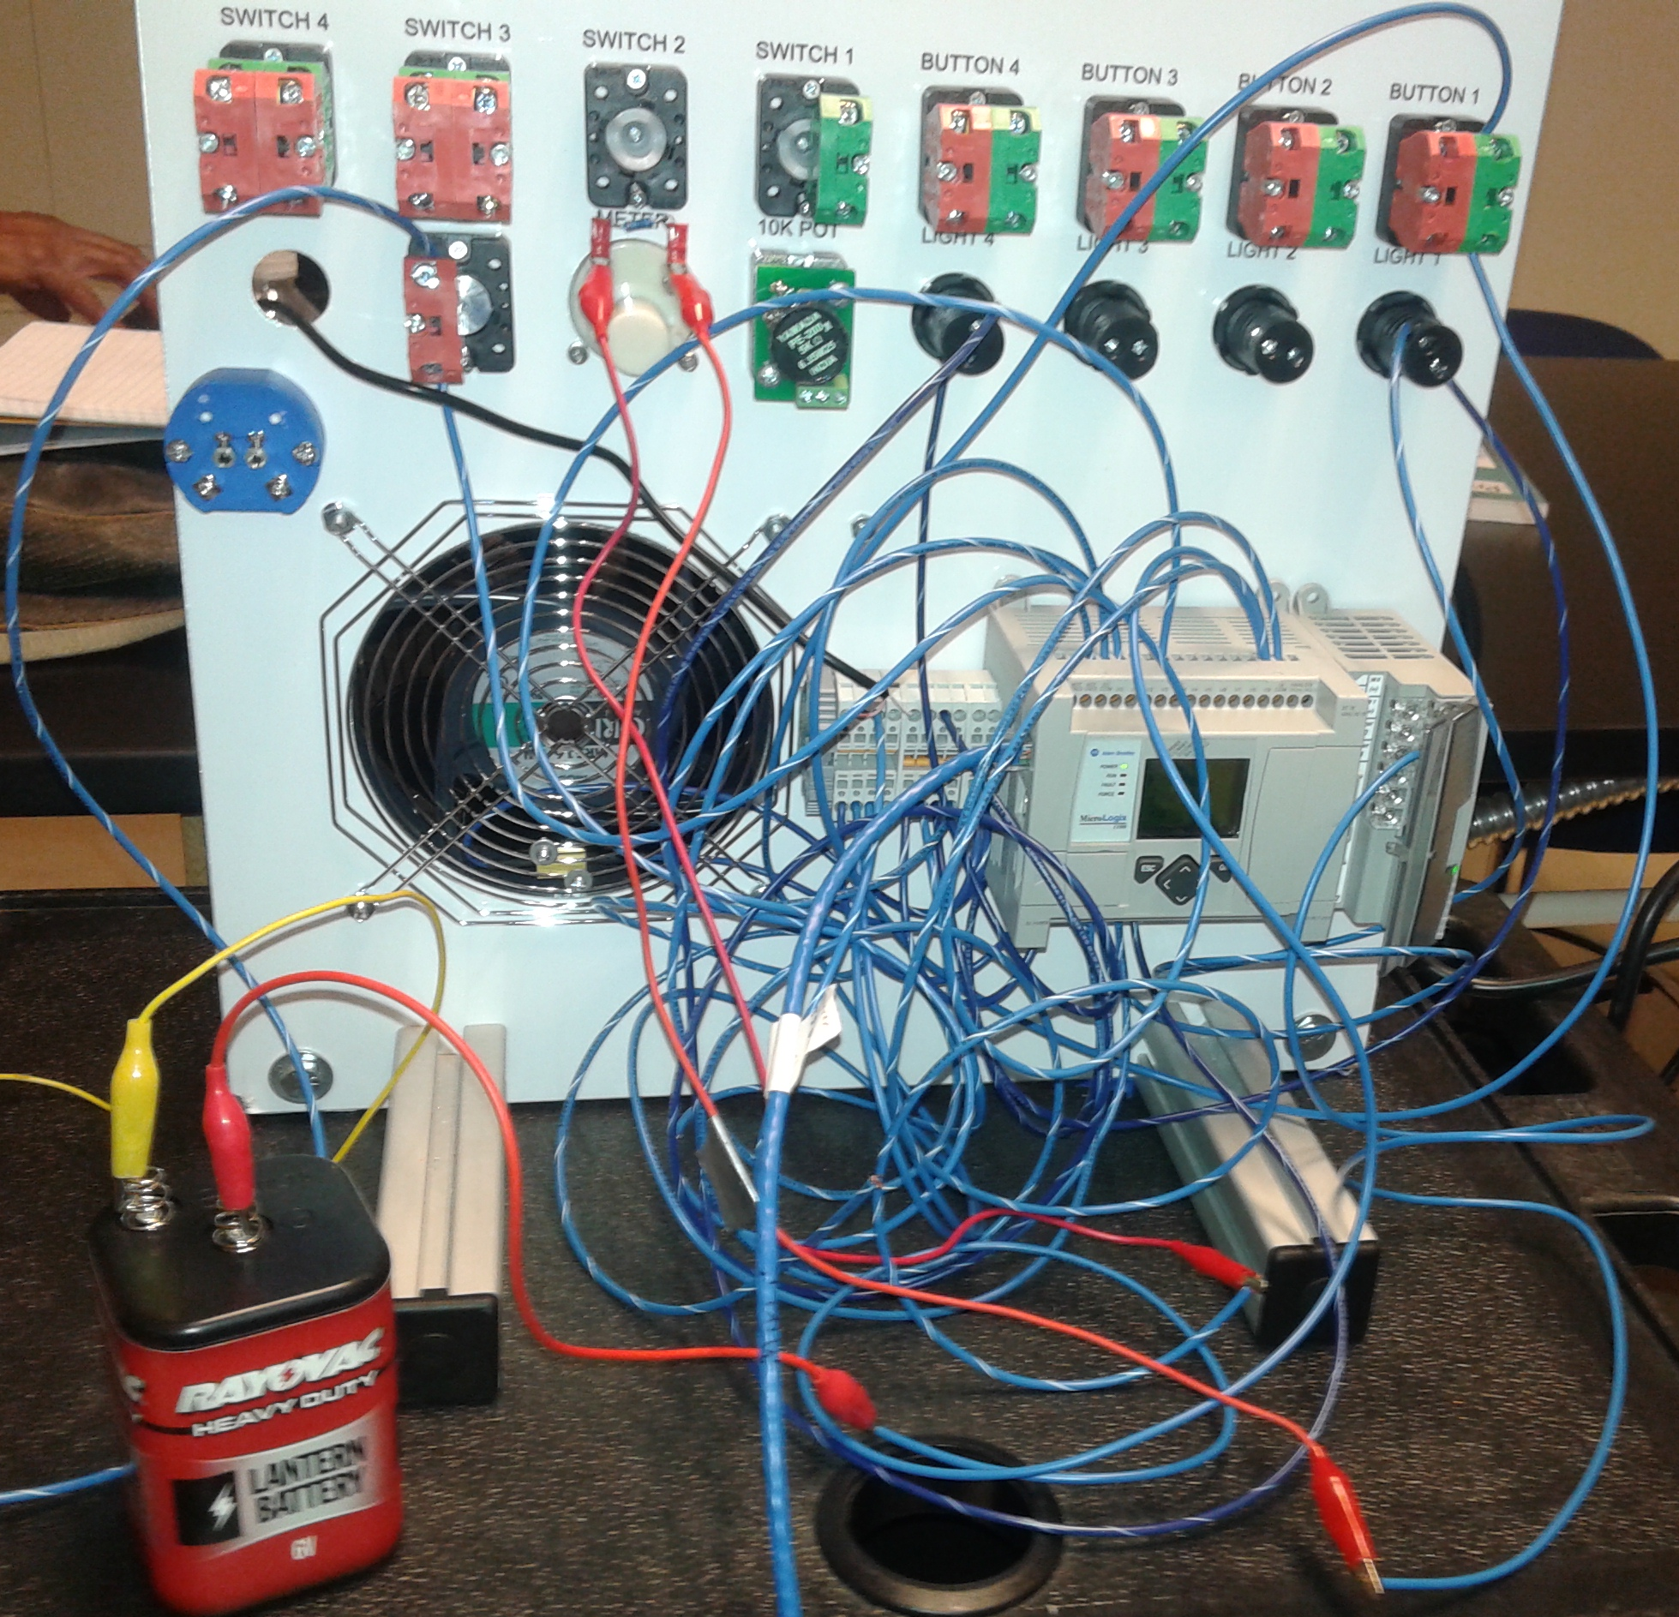

Step 7: Picture of our setup
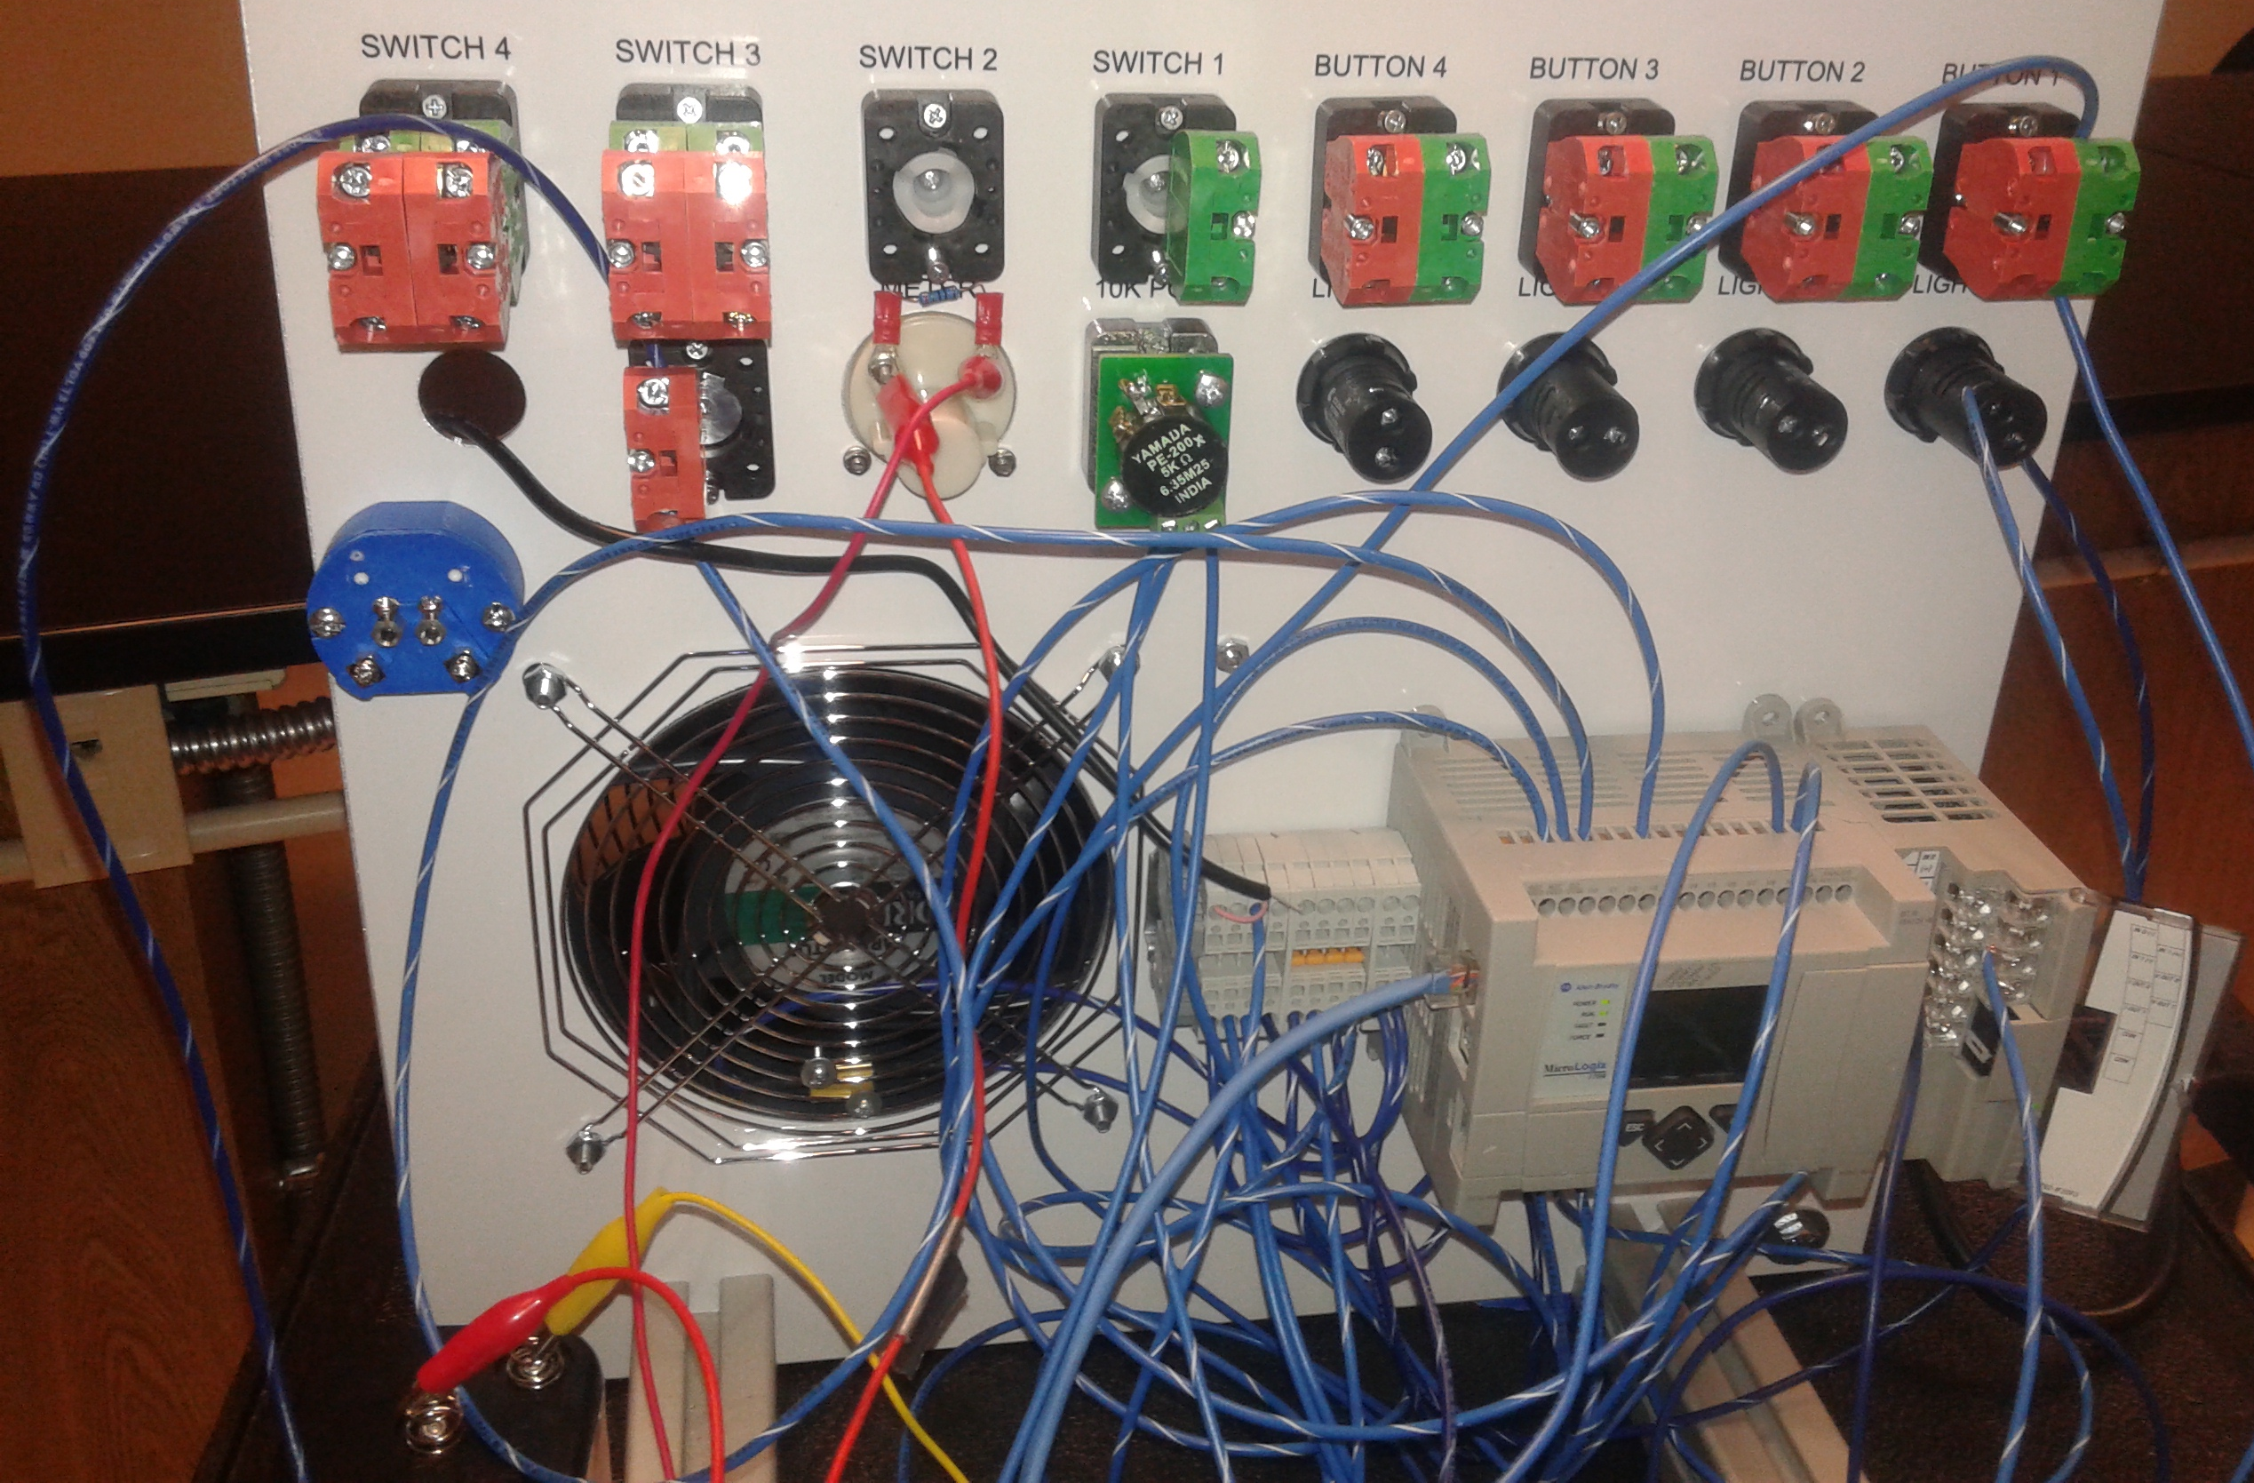

ANALYSIS QUESTIONS:
- Why did we have to scale the voltage reading from the battery to half maximum in step 5?
To account for the max voltage for the I/O analog module.
- What is the max voltage input and output for the analog module?
5 volts
- How is using a “word” level address different from a “bit” level address? Why is important to distinguish the two?
A bit level address allows a binary digit (1 or 0) to be assigned to a specific bit location in a PLCs memory. Word level addressing allows entire words to be addressed, and the bit part of the address is not usually used. Analog modules use a word addressing format.

